Face Recognition
Face recognition is a biometric which uses computer software to determine the identity of the individual. Face recognition falls into the category of biometrics which is “the automatic recognition of a person using distinguishing traits” [6]. Other types of biometrics include fingerprinting, retina scans, and iris scan.

Eigenface-based Recognition
2D face recognition using eigenfaces is one of the oldest types of face recognition. Turk and Pentland published the groundbreaking “Face Recognition Using Eigenfaces” in 1991. The method works by analyzing face images and computing eigenfaces which are faces composed of eigenvectors. The comparison of eigenfaces is used to identify the presence of a face and its identity.
There is a five step process involved with the system developed by Turk and Pentland. First, the system needs to be initialized by feeding it a set of training images of faces. This is used these to define the face space which is set of images that are face like. Next, when a face is encountered it calculates an eigenface for it. By comparing it with known faces and using some statistical analysis it can be determined whether the image presented is a face at all. Then, if an image is determined to be a face the system will determine whether it knows the identity of it or not. The optional final step is that if an unknown face is seen repeatedly, the system can learn to recognize it.
The eigenface technique is simple, efficient, and yields generally good results in controlled circumstances [1]. The system was even tested to track faces on film. There are also some limitations of eigenfaces. There is limited robustness to changes in lighting, angle, and distance [6]. 2D recognition systems do not capture the actual size of the face, which is a fundamental problem [4]. These limits affect the technique’s application with security cameras because frontal shots and consistent lighting cannot be relied upon.

3D Face Recognition
3D face recognition is expected to be robust to the types of issues that plague 2D systems [4]. 3D systems generate 3D models of faces and compare them. These systems are more accurate because they capture the actual shape of faces. Skin texture analysis can be used in conjunction with face recognition to improve accuracy by 20 to 25 percent [3]. The acquisition of 3D data is one of the main problems for 3D systems.

How Humans Perform Face Recognition
It is important for researchers to know the results of studies on human face recognition [8]. Knowing these results may help them develop ground breaking new methods. After all, rivaling and surpassing the ability of humans is the key goal of computer face recognition research. The key results of a 2006 paper “Face Recognition by Humans: Nineteen Results All Computer Vision Researchers Should Know About” are as follows:
- Humans can recognize familiar faces in very low-resolution images.
- The ability to tolerate degradations increases with familiarity.
- High-frequency information by itself is insufficient for good face recognition performance.
- Facial features are processed holistically.
- Of the different facial features, eyebrows are among the most important for recognition.
- The important configural relationships appear to be independent across the width and height dimensions.
- Face-shape appears to be encoded in a slightly caricatured manner.
- Prolonged face viewing can lead to high level aftereffects, which suggest prototype-based encoding.
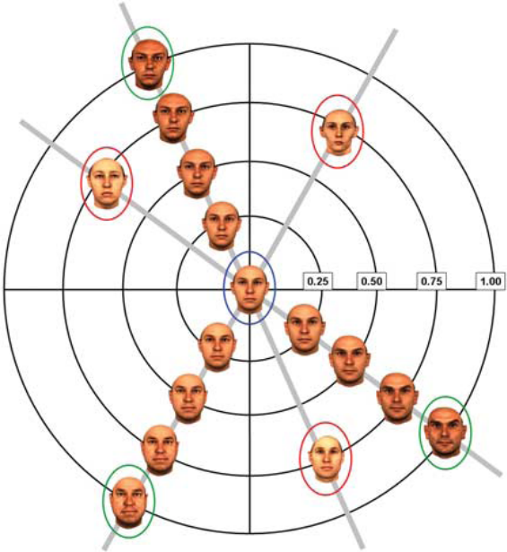
Staring at the faces in the green circles will cause one to misidentify the central face with the faces circled in red. This is an example of face aftereffects [8].

- Pigmentation cues are at least as important as shape cues.
- Color cues play a significant role, especially when shape cues are degraded.
- Contrast polarity inversion dramatically impairs recognition performance, possibly due to compromised ability to use pigmentation cues.

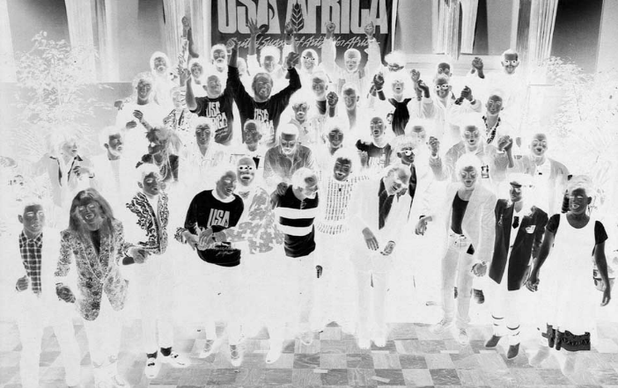
Photograph during the recording of “We Are the World.” This figure demonstrates how polarity inversion effects face recognition in humans. Several famous artists are in the picture including Ray Charles, Lionel Ritchie, Stevie Wonder, Michael Jackson, Tina Turner, Bruce Springstein, and Billy Joel though they are very difficult to identify.
- Illumination changes influence generalization.
- View-generalization appears to be mediated by temporal association.
- Motion of faces appears to facilitate subsequent recognition.
- The visual system starts with a rudimentary preference for face-like patterns.
- The visual system progresses from a piecemeal to a holistic strategy over the first several years of life.
- The human visual system appears to devote specialized neural resources for face perception.
- Latency of responses to faces in inferotemporal (IT) cortex is about 120 ms, suggesting a largely feed forward computation.
- Facial identity and expression might be processed by separate systems.

Face Recognition From a Law Enforcement Perspective
Facial recognition is attractive for law enforcement. It can be used in conjunction with existing surveillance camera infrastructure to hunt for know criminals. Face recognition is covert and non intrusive, opposed to other biometrics such as finger prints, retina scans, and iris scans [6]. This is especially important in conjunction with the law because faces are considered public. Comprehensive photo databases from mug shots or driver’s licenses already exist.
Because of difficulties face recognition has with respect to lighting, angle, and other factors, it is advantageous to attempt to get as high quality images with regard to these factors. Facetraps are a concept where cameras are strategically placed in order to obtain relatively controlled photographs [6]. Examples are placing cameras facing doorways, at airport check-ins, or near objects people are likely to stare at. These traps would aid face recognition software by helping to capture a straight frontal image which allow for higher accuracy of the system. Despite their potential benefit, there appears to be very little research done on facetraps.

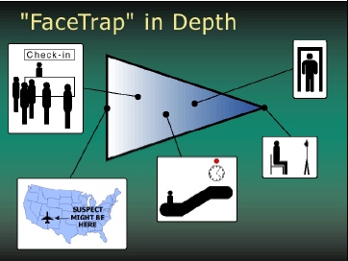
Figure depicts increasingly controlled environments from left to right. From left to right: suspect on a plane (no control), subject at a check-in counter, subject on an escalator staring at a flashing red bulb, subject passing through a doorway, subject sitting in front of a camera (perfect control) [6]

Some have questioned the legality of face scanning and have argued that such systems which are used to hunt to criminals in public places are an invasion of privacy. From a legal perspective, in the United States, one does not have a right to privacy for things shown in public [6]. “What a person knowingly exposes to the public. . . is not a subject of Fourth Amendment protection,” United States v. Miller, 425 U.S. 435 (1976). “No person can have a reasonable expectation that others will not know the sound of his voice, any more than he can reasonably expect that his face will be a mystery to the world,” United States v. Dionisio, 410 U.S. 1 (1973). These excerpts from Supreme Court decisions help to establish that face recognition is constitutional.
Face recognition must be improved further before it becomes a useful tool for law enforcement. It remains to be seen what the right balance is, socially speaking, between maximizing public safety and respecting individual rights.

Current Uses of Face Recognition
Face recognition systems used tied to surveillance cameras in Tampa, Florida and Newham, Great Britain [2]. Trials of the systems yielded poor results. The Newham system didn’t result in a single arrest being made in three years. Logan Airport, in Boston, performed two trials of face recognition systems. The system achieved only 61.7% accuracy [5]. Australian customs recently rolled out its SmartGate system to automate checking faces with passport photos. Google is testing face recognition using a hidden feature in its image searching website [7]. Google purchased computer vision company Neven Vision in 2006 and plans to implement its technology into its Picasa photo software.

[1] Matthew A. Turk, Alex P. Pentland, "Face Recognition Using Eigenfaces," Proc. IEEE Conference on Computer Vision and Pattern Recognition: 586–591. 1991.

[2] Michael Kraus, "Face the facts: facial recognition technology's troubled past--and troubling future," The Free Library, 2002.

[3] Mark Williams, "Better Face-Recognition Software," Technology Review, May 30, 2007.

[4] Trina D. Russ, Mark W. Koch, Charles Q. Little, "3D Facial Recognition: A Quantitative Analysis," 38th Annual 2004 International Carnahan Conference on Security Technology, 2004.

[5] Ryan Johnson, Kevin Bonsor, "How Facial Recognition Systems Work," How Stuff Works, 2007.

[6] John D. Woodward, Jr., Christopher Horn, Julius Gatune, Aryn Thomas, “Biometrics, A Look at Facial Recognition,” RAND, 2003.

[7] “New: Google Image Search Categories,” Google Blogoscoped, May 28, 2007.

[8] Pawan Sinha, Benjamin Balas, Yuri Ostrovsky, and Richard Russell, "Face Recognition by Humans: Nineteen Results All Computer Vision Researchers Should Know About," Proceedings of the IEEE, Volume: 94, Issue: 11, 2006.

